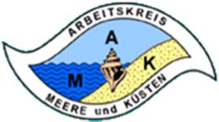

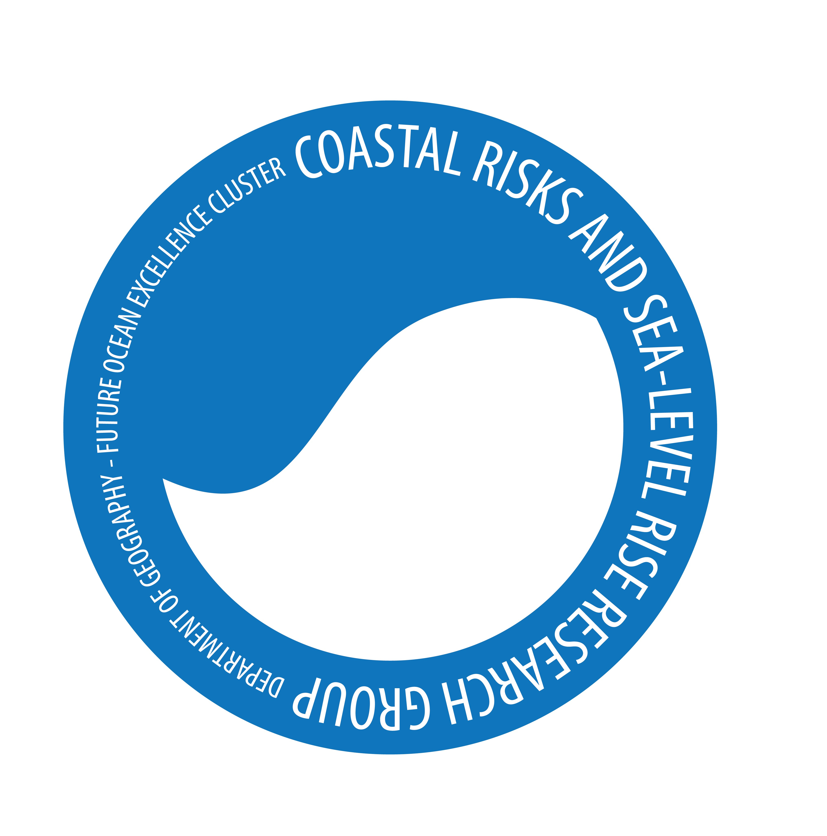

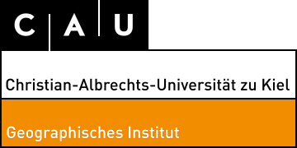

**Invitation and call for papers for the 35th Annual Conference**

**of the Working Group „Geography of Seas and Coasts“ (AMK)**

**Kiel, April 19 to 22, 2017,**

www.amk-geographie.de

Veranstaltungso **Venue:** Wissenschaftszentrum Kiel; Fraunhoferstraße 13, 24118 Kiel

**Organization**: Prof.Dr. Horst Sterr, Prof.Dr. Athanasios Vafeidis; Prof.Dr. Felix Müller Dr. Marion Kruse, Dr. Kai Ahrendt; Dr. Peter Krost

Programm: **Program:** Wednesday April 19, 2017: Icebreaker-Event

Thursday and Friday April 20 and 21, 2017:

Presentations, Poster Session, Dinner

Saturday, April 22, 2017 :

Field Trip at Baltic Sea Coast outside Kiel covering most topics below

**Registration Deadline:** **March 1st 2017**

When registering for the lectures and posters, please include an English abstract (maximum length one A4 page). Registration for conference participation is possible up to the start of the conference.

.

**Topics and Issues:** A wide spectrum of coastal and marine themes, including

* Historic / Long-term Coastal Development,
* Coastal Dynamics and Processes
* Climate Change, Sea Level Rise, Coastal Hazards
* Use and Protection of Coasts
* Marine Aquaculture & Ressource Use (Mussels, Algae, Fish, Beach Wrack)
* Spatial Planning & Risk Management
* Ecosystem Services and Indicators
* Water Quality and Marine Litter

Conference languages are English and German.

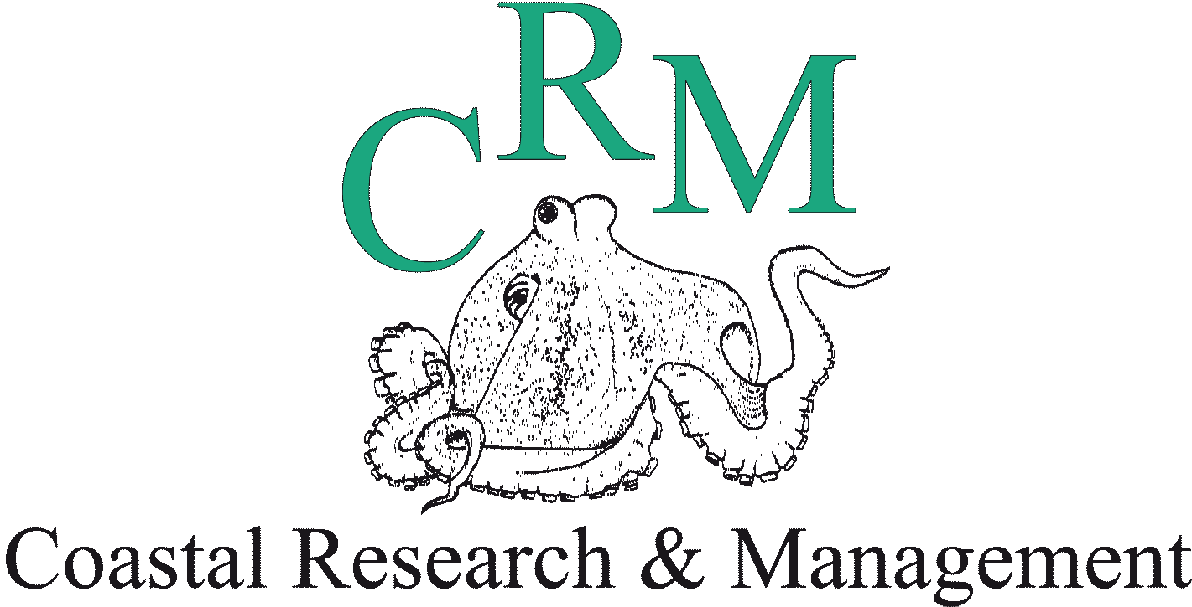

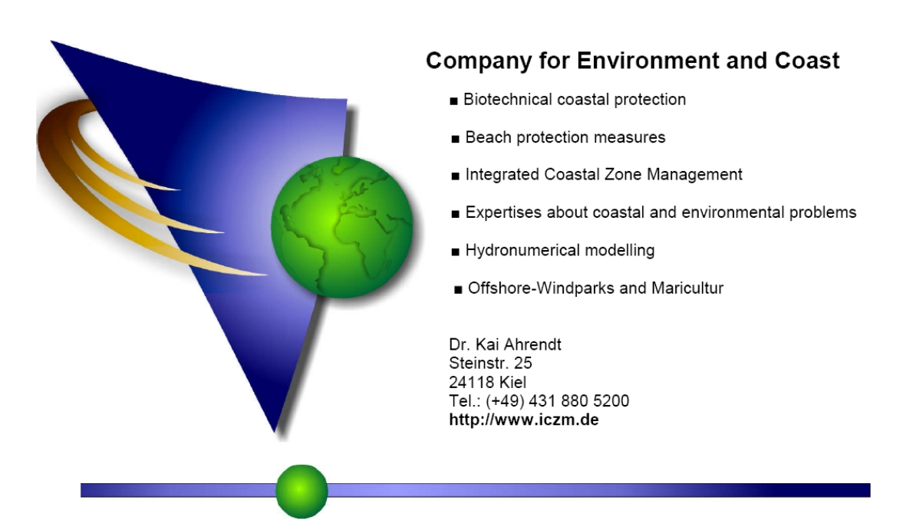

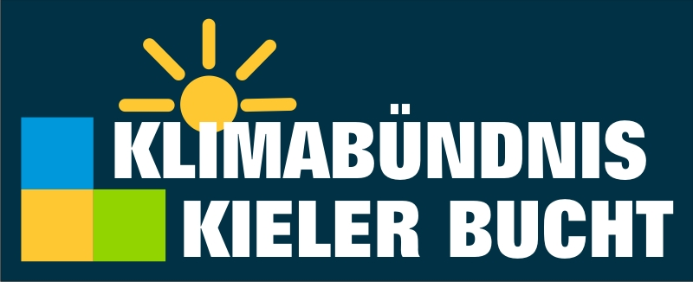





**Registration for the 35th Annual Conference**

**of the Working Group “Geography of Seas and Coasts“ (AMK)**

I hereby register for participation in the 35th Annual Conference for the Working Group ´Geography of Seas and Coasts’ from April 19 to 22, 2017 in Kiel.

Last Name, First Name: ………………………………………………………………

Organization: ………………………………………………………………

Address: ………………………………………………………………

Postal Code and City: ………………………………………………………………

Telephone: ………………………………………………………………

Email Address: ………………………………………………………………

I would like to give a presentation ( )

I would like to present a poster. ( )

Title of presentation or Poster: …………………………………………………………………

……………………………………………………………………………………………………………

……………………………………………………………………………………………………………

Please send the registration form plus abstract for lecture or poster via email to the conference organizers at [**sterr@geographie.uni-kiel.de**](mailto:sterr@geographie.uni-kiel.de); with reference to **AMK 2017**

**The participation fee is € 70 and for students € 30**

The fee includes participation in the Icebreaker event on April 19 as well as coffee/tea, cold drinks, sandwiches and cake on April 20 and 21.

Participation in the excursion on April 22 is 15 Euro (without food)

I plan to participate in the Icebreaker – event on April 19 2017: ( ) yes ( ) no

I plan to participate in the excursion on April 22, 2017 (15€) ( ) yes ( ) no

Please transfer the total amount until **April 1st 2017** to the following account:

HORST STERR; Account: DE30200300000633900790 ; BIC/SWIFT: HYVEDEMM300; HypoVereinsbank, Kiel

Reference: AMK 2017